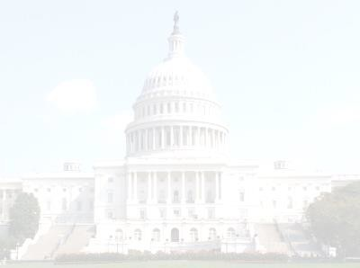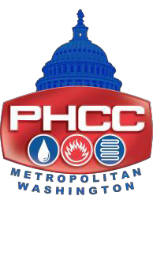

**Metropolitan Washington Plumbing-Heating-Cooling Contractors**

***Dedicated to the Promotion, Advancement, Education and Training of the Industry.***

Metropolitan Washington PHCC

2020 Industry Associate Membership Application

Contact Name (person to receive MWPHCC Association mailings) and title:

Company Name:

Mailing Address:

City: State: Zip:

Phone: Fax:

E-mail:

Website:

Industry Associate Membership Invoice

**Dues Amount:** $450.00 USD

Member dues are valid through December 2020

**Method of Payment:**

* Check Enclosed (payable to MWPHCC) Amount: $ Mail payment to: 5510 Tuxedo Road / Hyattsville, Maryland 20781-1318

**5510 Tuxedo Road / Hyattsville, MD. 20781-1318, 301/278-2962** [**www.mwphcc.org**](http://www.mwphcc.org/) ** E-mail:** [**sue@mwphcc.org**](mailto:sue@mwphcc.org)